
Department of Electrical and Computer Engineering
North South University

Directed Research
Instance-Aware Object Removal and Background Reconstruction Using Hybrid Inpainting with Comprehensive Evaluation

Md. Minhajul Islam ID# 2211022042
Azmain Iqtidar Arnob ID# 2211786042
Aqib Ahmed ID# 2211335042
Atikul Islam Nahid ID# 2211978042

Faculty Advisor:
Dr. Jilan Samiuddin
Assistant Professor
Department of Electrical & Computer Engineering
North South University
Spring, 2026

APPROVAL
Md. Minhajul Islam (ID # 2211022042), Azmain Iqtidar Arnob (ID # 2211786042), Aqib Ahmed (ID # 2211335042) and Atikul Islam Nahid (ID # 2211978042) from Electrical and Computer Engineering Department of North South University, have worked on the Directed Research Project titled “Instance-Aware Object Removal and Background Reconstruction Using Hybrid Inpainting with Comprehensive Evaluation” under the supervision of Dr. Jilan Samiuddin partial fulfillment of the requirement for the degree of Bachelors of Science in Engineering and has been accepted as satisfactory.

Supervisor’s Signature

…………………………………….
Dr. Jilan Samiuddin
Assistant Professor
Department of Electrical and Computer Engineering
North South University
Dhaka, Bangladesh.

Chairman’s Signature

…………………………………….
Dr. Mohammad Abdul Matin
Professor
Department of Electrical and Computer Engineering
North South University
Dhaka, Bangladesh.

DECLARATION

This is to declare that this project/directed research is our original work. No part of this work has been submitted elsewhere partially or fully for the award of any other degree or diploma. All project related information will remain confidential and shall not be disclosed without the formal consent of the project supervisor. Relevant previous works presented in this report have been properly acknowledged and cited. The plagiarism policy, as stated by the supervisor, has been maintained.

Students’ names & Signatures

1. Md. Minhajul Islam

_ _ _ _ _ _ _ _ _ _ _ _ _ _ _ _ _
2. Azmain Iqtidar Arnob

_ _ _ _ _ _ _ _ _ _ _ _ _ _ _ _ _
3. Aqib Ahmed

_ _ _ _ _ _ _ _ _ _ _ _ _ _ _ _ _
4. Atikul Islam Nahid

_ _ _ _ _ _ _ _ _ _ _ _ _ _ _ _ _

ACKNOWLEDGEMENTS
The authors would like to express their heartfelt gratitude towards their project and research supervisor, Dr. Jilan Samiuddin, Assistant Professor, Department of Electrical and Computer Engineering, North South University, Bangladesh, for his invaluable support, precise guidance and advice pertaining to the experiments, research and theoretical studies carried out during the course of the current project and also in the preparation of the current report.
Furthermore, the authors would like to thank the Department of Electrical and Computer Engineering, North South University, Bangladesh for facilitating the research. The authors would also like to thank their loved ones for their countless sacrifices and continual support.

ABSTRACT
Instance-Aware Object Removal and Background Reconstruction Using Hybrid Inpainting with Comprehensive Evaluation

Realistic object removal from complex multi-person scenes is a very challenging problem due to difficulties in proper segmentation and high-quality background reconstruction. Here inpainting methods actually makes blurred or texture-inconsistent outputs.Diffusion-based approaches get confused when large regions of the image are removed, especially in real-world scenarios involving multiple interacting individuals. As a result, we approach a multi-stage instance-aware object removal framework that brings together detection, segmentation, and hybrid inpainting techniques. The proposed method first finds person instances using a deep learning-based object detector, and creates mask generation and refine it to ensure the accurate object boundaries. Moreover ,We have applied a hybrid inpainting strategy , where a global inpainting model reconstructs the overall photo structure, and a diffusion-based model performs local refinement to enhance fine details and makes it visually realistic. To address large-mask reconstruction challenges, context-aware masking and iterative refinement are incorporated as additional improvements. We have tested the method on a subset of real-world images containing multiple persons and measure how good the results are where it got an average PSNR of approximately 18.17, SSIM of 0.713, and OUT-SSIM of 0.774.This is showing decent reconstruction quality and keeping the untouched areas of non-masked regions. The proposed approach produces more visually coherent outputs compared to baseline methods, particularly in scenes with moderate mask sizes. However, An average residual detection count of 6.96 from residual detection analysis shows that complete removal is quite challenging and highlighting limitations in fully suppressing object presence. Overall, this works shows that combining the global and local inpainting techniques in a structured pipeline which basically improves reconstruction quality in complex scenes while providing a more comprehensive evaluation strategy that considers both visual quality and residual object presence.

TABLE OF CONTENTS
APPROVAL 2
DECLARATION 3
ACKNOWLEDGEMENTS 4
ABSTRACT 5
TABLE OF CONTENTS 6
LIST OF FIGURES 8
LIST OF TABLES 9
Chapter 1 Introduction 1
1.1 Background and Motivation 1
1.2 Purpose and Goal of the Project 2
1.3 Organization of the Report 4
Chapter 2 Research Literature Review 5
2.1 Existing Research and Limitations 5
Chapter 3 Methodology 8
3.1 System Design 8
3.2 Hardware and Software Components 13
3.3 Software Implementation 16
Chapter 4 Experiment, Result, Analysis and Discussion 19
4.1 Experimental Setup 19
4.2 Baseline Comparison 20
4.3 Progressive Removal Analysis 22
4.4 Multi-Method Comparison and Trade-off Analysis 24
4.5 Stage-wise Development of the Final Pipeline 28
4.6 Final Proposed Method Evaluation 32
4.7 Discussion 35
Chapter 5 Conclusions 36
5.1 Summary 36
5.2 Limitations 37
5.3 Future Improvement 39
References 41

LIST OF FIGURES
Figure 1: Goal Illustration 2
Figure 2 : Mask refinement process 9
Figure 3 : Global–local reconstruction strategy 10
Figure 4: Residual-aware evaluation 11
Figure 5 : Proposed system architecture 12
Figure 6: Baseline comparison visual grid 21
Figure 7: Metric comparison between Method A & Method B 22
Figure 8: Per-image win-rate comparison between Method A & Method B 23
Figure 9: Per-image performance comparison of Methods A–D 25-26
Figure 10: Trade-off analysis of reconstruction quality and object removal effectiveness under increasing scene complexity. 24
Figure 11: Stage-wise evolution of the proposed instance-aware object removal pipeline 27-28 Figure 12: Qualitative results of the final proposed pipeline 31

LIST OF TABLES
Table I: Software And Tools Used 15
Table II: Hyperparameters Used in the Proposed Framework 15
Table III: Quantitative comparison of five pretrained inpainting baselines evaluated on the same image subset. 20
Table IV: Quantitative comparison between single-shot removal and progressive instance-wise removal. 23
Table V: Multi-method comparison showing the trade-off between reconstruction quality and residual object removal. 24
Table VI: Final performance summary of the proposed Stage 2 V2 pipeline
on evaluated samples. 32

Chapter 1 Introduction

Background and Motivation
Digital image editing has become a vital area of computer vision as modern applications often require automatic modification, restoration, and reconstruction of visual content. Among these tasks, object removal is one of the hardest tasks in image editing. The main goal of object removal is not only to remove a specific object from an image, but also to reconstruct the missing background in such a way that the edited region becomes visually consistent so that it looks natural. This task becomes mostly difficult when the target objects are large and also when multiple objects are present, or whether the removed region contains complex textures, lighting variations, and structural information.
In real-world images, human subjects often occupy a large portion of the scene. Examples include group photographs, crowded public environments, and social events.For removing one or more persons from the images requires proper object localization, precise mask generation, and realistic background reconstruction. Recent advances in object detection models such as YOLO have vitally improved real-time instance detection performance [1], while segmentation models such as the Segment Anything Model (SAM) have enabled highly accurate mask generation for arbitrary objects [2]. Despite these advancements, generating visually consistent background reconstruction after the object removal remains a challenging problem.
Traditional inpainting methods, such as Telea and Navier–Stokes-based approaches, are computationally very efficient and perform well for the small missing regions, but they often fail to preserve texture consistency and also semantic structure in the large masked areas. Learning-based approaches such as LaMa have improved global image reconstruction by utilizing large receptive fields and advanced convolutional designs [3]. More recently, diffusion-based generative models, including Stable Diffusion and related methods, have become very good in realistic textures and semantic content [4], [5]. However, these models are generally sensitive to mask size and quality, and they don't perform well when large portions of the image are removed, often resulting in unnatural or structurally inconsistent outputs.
However, this research is motivated by the limitations of existing methods in handling the complex multi-person scenes. Instead of treating object removal as a single-step inpainting problem, this project proposes a structured, instance-aware pipeline that integrates detection, segmentation, mask refinement, and hybrid inpainting. By combining global reconstruction and local refinement, the proposed approach helps to improve the visual consistency while addressing the large-mask failure problem observed in diffusion-based methods.

Purpose and Goal of the Project
This project’s aim is to create a scalable and robust instance-aware object removal and high-fidelity background reconstruction framework on real-world images containing multiple persons like those in figure-1. While the state of the art detection and segmentation models (e.g., YOLO [1], SAM [2]) do well at identifying and isolating a multitude of objects, creating a new background post-object removal is quite difficult, especially for large portions of the image that have been impacted. Classical inpainting methods do not work well for large or semantically complicated regions, while the diffusion approach of generating realistic textures has issues with retaining structural integrity globally when applied to large masks [4], [5]. The above demonstrates that the process could benefit from a more organized and hybrid model.

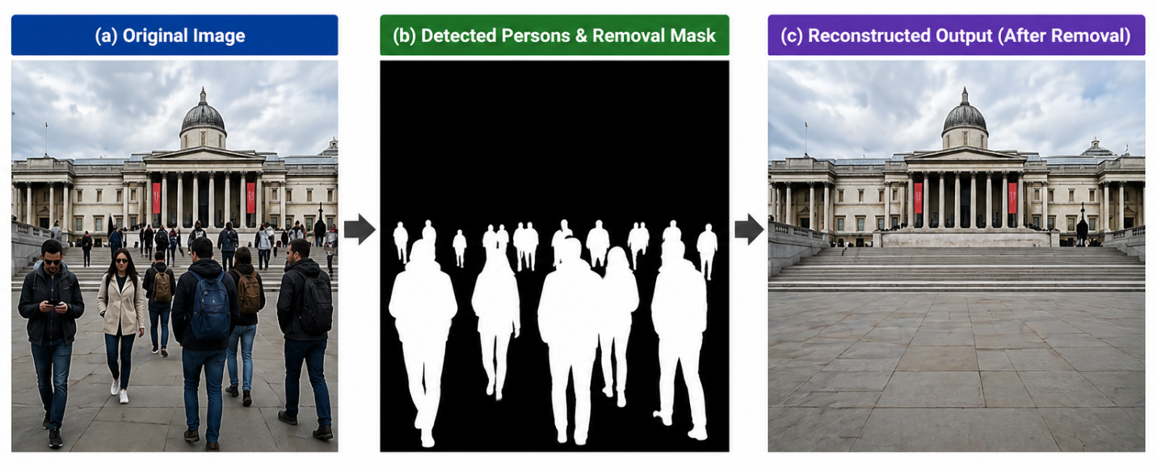
Figure 1: Goal Illustration
This study aims to create a multi-stage object removal approach that combines instance level image analysis, mask refinements and hybrid inpainting to result in better image reconstructions as seen in Figure-1 . The proposed architecture uses a global inpainting model based on techniques like LaMa [3] first in reconstructing the entire scene, then applying a diffusion-based local refinement process to provide realistic details. By integrating both the global and local strategies, it attempts to combine the positive attributes of each while compensating for their limitations.
A key additional goal of this research is to develop a more effective evaluation method. Standard evaluative methods rely primarily on image-similarity metrics (e.g., PSNR, SSIM) for measuring image reconstruction accuracy, but fail to provide accurate information about whether there are still ‘perceptible’ or ‘semantic’ representations remaining from an object that has been removed from the original image. To address this limitation, a newly proposed evaluative method based on the detection of residuals has been developed; it uses an object detection (i.e. person) computational model to evaluate the evidence of formerly detected objects by identifying whether the objects are detectable (could have been detected) from the reconstructed image . This enhances the reliability and practicality of the evaluators.
Summary of the key findings and contributions of this project, Firstly it is an instance-aware Multi-stage Object Removal framework consisting of four stages: detection, segmentation, mask refinement and hybrid inpainting. The second part of the paper presents the methodology behind a Hybrid Global & Local Inpainting strategy . That combines the structural reconstruction properties of LaMa with the detail enhancement capabilities of diffusion models to create a inpainting method. Thirdly, it presents an evaluation methodology based on residual detection and whether there are residuals (parts of objects) left behind rather than solely focusing on assessing image quality.
The major contribution and the originality of this work was in the integration of an organized pipeline, specifically designed to remove multiple objects from scenes containing multiple-presentations of humans at once. Unlike conventional single-step object removal approaches, we developed a coordinated multi-step approach where images are processed through a sequence of mutually dependant stages. As a result, the quality of the reconstructed regions in the image has increased significantly and has addressed the fatal failure of large masks. Our method produced very strong reconstruction quality as evidenced by the complete reconstruction of PSNR scores averaging approx 18.17 and an SSIM score of 0.713 for the reconstructed regions, and a strong degree of non-masking area with an OUT-SSIM score of 0.774. Residual detection analysis also indicated that even though we completely removed objects from complex scenes, effectively removing the detected objects was still very difficult and highlights a significant limitation of the current method, and identified a need for additional investigation into this problem.

Organization of the Report
This report is divided into five chapters like a standard research paper.
- Chapter 1 explains the background of the topic, why it is important, and what the project aims to achieve. It also describes the main challenges of removing objects (especially in scenes with many people).
- Chapter 2 reviews previous research on related topics like object detection, segmentation, image filling (inpainting), and AI image generation. It also points out where current methods are weak, especially with large missing areas and complex real-life images.
- Chapter 3 explains the proposed method in detail—how the system is built, how data is prepared, and how each step works (detection, segmentation, mask improvement, and image reconstruction).
- Chapter 4 shows the experiments and results. It compares the method with others, analyzes performance, and discusses both successful and failed cases.
- Chapter 5 gives the conclusion, summarizing what was achieved, what limitations still exist, and what can be improved in the future.

Chapter 2 Research Literature Review

2.1 Existing Research and Limitations
Object removal and image inpainting have been extensively studied in computer vision, with methods evolving from classical diffusion-based techniques to deep learning and modern generative models. This section reviews key research contributions in object detection, segmentation, and inpainting, along with their datasets, reported performance, and limitations in handling complex multi-person scenes.
Initially, image inpainting techniques relied heavily on the use of partial differential equations (PDE). The first Navier-Stokes method for inpainting images was presented by Bertalmio et al [6]. They use the image gradient to propagate information from the rest of the image into the area of missing information in order to maintain the structure of the image as much as possible. Telea [7] also introduced an algorithm based on a fast marching technique; this algorithm allows for increased speed while providing structures that are close to the actual structure of the object being removed. Both of these algorithms were designed to work with relatively small masks and with images that are simple, therefore the overall results produced by both methods will be acceptable visually in most situations. As both methods require no semantic understanding, they will be unable to successfully inpaint areas where significant portions of the image are missing. In other words, both methods will achieve relatively high similarity (i.e., SSIM scores above 0.70 when being evaluated with small masks) with very few visual artifacts being produced for simple inpainting areas. However, for more complicated areas where a large object is to be removed there will be poor quality textures produced, i.e. blurry and unrealistic.
The introduction of deep learning significantly improved inpainting performance. Pathak et al. [8] proposed Context Encoders, trained on large-scale datasets such as ImageNet, using an encoder–decoder architecture combined with adversarial loss. Their model showed that it could create content that was both semantically valid and more visually realistic than traditional methods. One downside of their models was that they produced blurry images and were limited in terms of the perceptual quality of their outputs . They had difficulty capturing small details. Yu et al. [9] introduced inpainting via gated convolutional kernels, using the Places2 and CelebA-HQ datasets to produce better results with irregular masks, and provided benchmarks for their inpainting results based on standard datasets and mask sizes, achieving good evidence through SSIM (in particular, around 0.80 when testing datasets with moderate to large masks). More importantly, they provided structural consistency improvements as well, which is generally a significant trade-off.
Then came a major advance: inpainting using Fourier convolutions to provide global context, as introduced by Suvorov et al. [3] through LaMa, which was developed on the Places2 dataset and shown to perform strongly across all benchmarks tested in terms of perceptual quality (i.e., approx. 0.10–0.15 LPIPS for standard datasets) and structural consistency when compared with prior CNN-based solutions. Especially effective when dealing with large masks, as it is capable of capturing global context for reconstructive processes. Though LaMa has been capable of producing a high-quality structural representation mostly. Images produced with it typically exhibit artificially smooth textures and lack high-quality semantic information (no fine details) ,when created in complex regions of the reconstruction of the image.
Parallel to inpainting research, object detection and segmentation have also seen rapid development. The YOLO framework, introduced by Redmon et al. [1], demonstrated real-time object detection with competitive accuracy, achieving mean Average Precision (mAP) of around 63.4% on the PASCAL VOC dataset. More recent versions have significantly improved detection performance on large-scale datasets such as MS COCO. The Segment Anything Model (SAM) introduced by Kirillov et al. [2] is an important development for segmentation and has been trained on billions of masks from a variety of datasets. The model exhibits large generalization capabilities and can create high-quality segmentation masks for a variety of objects. While detection and segmentation models are able to localize objects with precision, they do not solve the issue of accurately reconstructing the background after an object has been removed from the image.
In addition, diffusion-based generative model approaches have recently achieved state of the art results in regard to image synthesis and inpainting. Rombach et al. [4] presented the Latent Diffusion Model (LDM), which is trained on large-scale datasets such as LAION-5B and produces high-quality synthetic images with computational efficiency. Throughout their evaluation of RePaint, a diffusion-based inpainting approach, Lugmayr et al. [5] employed the CelebA-HQ and ImageNet datasets. Their experiments indicate that this method produces very good perceptual quality with LPIPS scores of about 0.03–0.05 for moderate mask sizes (i.e., 512×512 ppi) and improved realism over the results obtained through GAN-based techniques. Even after these advantages, diffusion-based inpainting techniques can have significant limitations, such as producing unrealistic or structurally inconsistent images when the masked region size is too large and being computationally expensive , also sensitive to prompts and mask quality.
Recent research has attempted to combine multiple techniques to improve inpainting performance. Most hybrid models attempt to integrate structural reconstruction techniques with methods that generate refinements for those reconstruction techniques. However many methods currently available do not include instance detection, mask refinement, and reconstruction methods all in one workflow or pipeline. Many papers also primarily rely on PSNR and SSIM as their measuring methods and neither of them captures what is left over from the removed object. This is an important limitation for object removal operations because visual continuity does not imply successful object removal.
From reviewing the literature, it is possible to identify several common limitations of methods used to remove objects. The traditional methods are not capable of reconstructing large and complex areas with structural integrity. While methods based on Convolutional Neural Networks have been able to improve upon the structural integrity improvements of traditional techniques, these methods typically do not generate fine detail in the newly reconstructed area. Models based on diffusion are able to create textures that look convincing, but have difficulty in handling large masks when reconstructing objects and maintaining the structural integrity of the remaining pixels after creating the texture. Models based on detection or segmentation do not currently provide any reconstruction capabilities. Most methods published do not have a complete evaluation strategy that addresses whether or not an object is still visible after being removed.
These limitations serve as motivation for the work being proposed here. It is hoped that this research will provide a novel (multi-phase) stage-based framework for object removal instance aware detection, segmentation, mask refinement. Also provides hybrid methods and techniques to make refinements of the newly reconstructed object via generating structure. Includes residual aware validation processes for evaluating whether the object completely removed or not from the image. This research also seeks to address the limitations of current methods in the context of object removal from a multi-person scene by providing a combined global reconstruction method.

Chapter 3 Methodology

3.1 System Design
The proposed system is designed as a multi-stage framework to remove objects and reconstruct backgrounds in real-world images with multiple people. The main objective of the system is to remove selected human instances from an image and reconstruct the missing background in a visually coherent and structurally consistent manner. Usually in inpainting pipelines,at first a image and a binary mask are directly passed to a inpainting model, then the model attempts to fill the missing region in a single step. However, this approach becomes unreliable when the target region is large and several persons overlap and also when the mask boundary is irregular. During the early experiments of this project, it was observed that single-shot removal often produced distorted textures, blurry regions, and incomplete object suppression, especially when the combined person mask occupied a large portion of the image. Therefore, the final proposed system is designed as a structured pipeline where different stages—such as detection, segmentation, mask refinement, reconstruction, and evaluation—are handled separately but work together in a coordinated way to achieve better and more realistic results.
The system starts by taking a real-world image from a multi-person subset of the COCO dataset. These images vary in complexity and often include group photos, crowded scenes, different lighting conditions, cluttered backgrounds, and overlapping people. Since the goal is to remove specific individuals, the first step is automatically detecting and separating all people in the image. This is done using YOLOv8x-seg, which finds each person and creates a mask around them. This removes the need for manual labeling and makes the process scalable for larger datasets. In earlier experiments, SAM-based methods and click-guided segmentation were also tested. But the final system uses YOLOv8x-seg because it can both detect and segment objects in a single automated step and make the pipeline more efficient and consistent.
After the person instances are detected, the generated masks are combined into a unified removal mask. This mask mainly shows the regions that need to be removed and reconstructed. However,raw segmentation masks are not always directly suitable for inpainting. Limitations like small holes, fragmented edges, rough boundaries, or incomplete coverage around body parts. If such masks are passed directly into an inpainting model, the final output may contain visible halos, remaining object boundaries, or unnatural transitions between the reconstructed and original regions. As a result, mask refinement is a critical component of the proposed system which is shown in Figure-2. The mask refinement step cleans and improves the mask. It fixes small holes and removes unwanted noise using simple image-processing techniques. Then it slightly expands the mask so that even tiny edge parts of the object are fully covered. Finally, it smooths the edges so the transition between the removed area and the rest of the image looks more natural and less sharp.

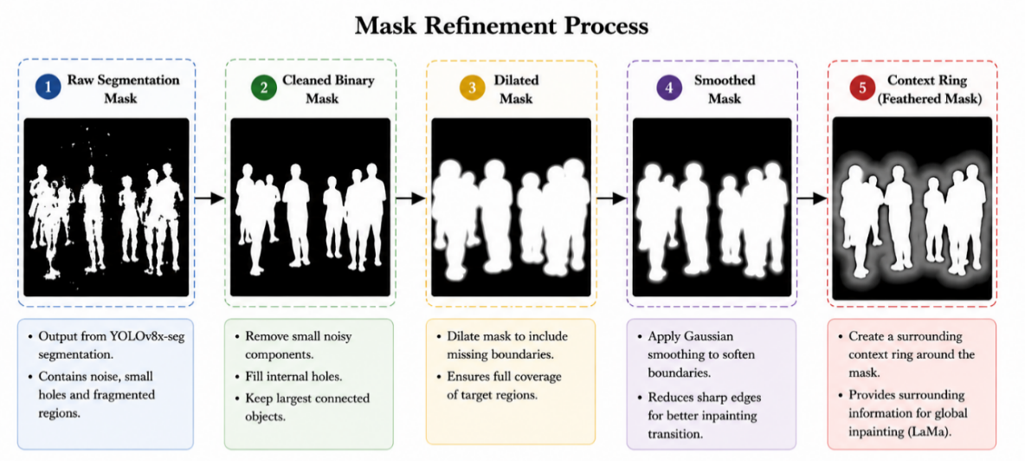
Figure 2: Mask refinement process

A context-aware mask representation is also used in the system. A surrounding context region is generated around the object boundary to the main binary removal mask. This context ring helps to guide the reconstruction process by identifying the nearby image area which should influence the generated background. The use of contextual information is important because object removal does not depend only on the pixels inside the mask. The reconstructed region must be consistent with the surrounding texture, lighting, perspective and scene structure. Therefore, the context ring provides a more informative spatial reference for later reconstruction and evaluation.
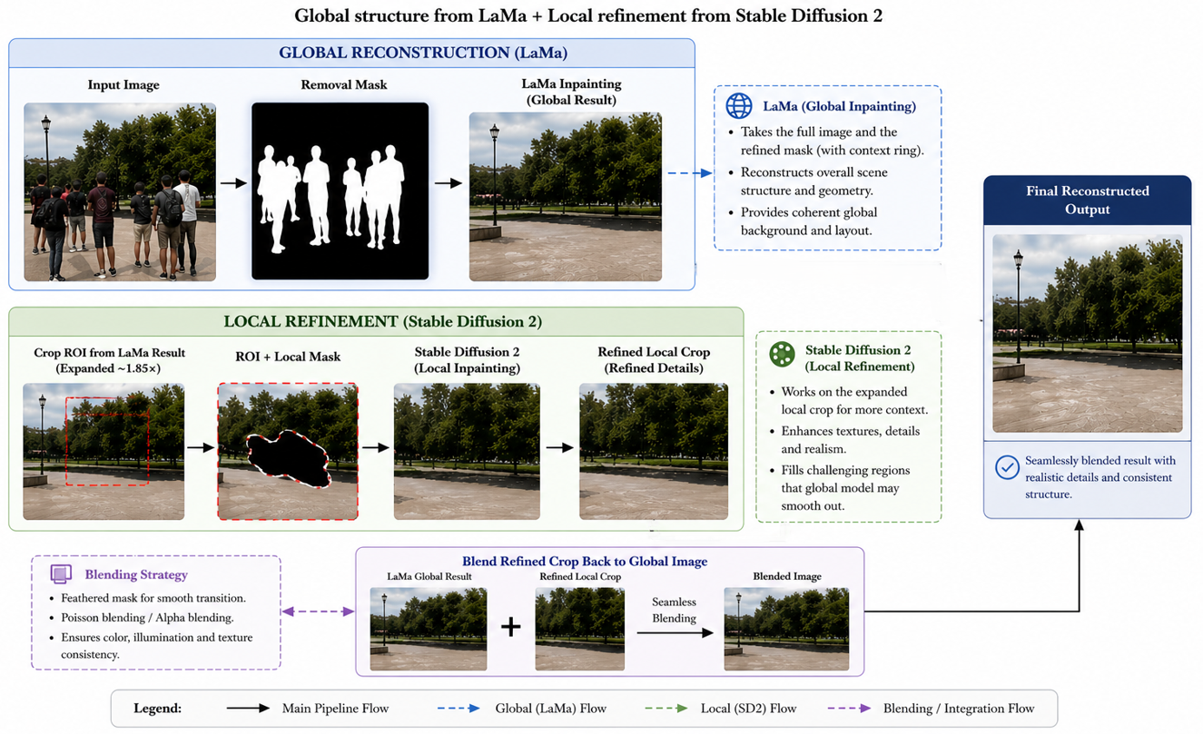
Figure 3: Global–local reconstruction strategy
The reconstruction stage of the system follows a hybrid global–local design showed in Figure 3. The first reconstruction stage uses LaMa as a global inpainting model. LaMa is applied to the full image with the refined removal mask and is responsible for reconstructing the overall background structure. This stage is important because it preserves global layout and produces a complete reconstructed image efficiently. In many cases, LaMa provides stable background continuation and avoids the extreme hallucination sometimes observed in diffusion-only inpainting. However, LaMa may produce overly smooth textures or limited fine details in complex regions. Therefore, the system does not rely only on LaMa as the final output.
To improve perceptual realism, the second reconstruction stage applies diffusion-based local refinement using Stable Diffusion 2 inpainting. Instead of using the diffusion model to create a complete image, it first will take a local crop around the area where something was removed and expand the crop many pixels out past the mask edge to add some additional pixel information based on the surrounding area. An approximate expansion ratio of 1.85 was used to include sufficient surrounding contextual information around the masked region.. The local crop will then be resized to 512x512 pixels and passed to the diffusion inpainting model. This method of using a local crop rather than creating a full image is less complex for the diffusion model because it will only generate pixels for the area that needs visual improvement instead of generating pixels for a complete scene.The diffusion stage uses the LaMa-generated output for the image structure and will increase the local image texture, blend, and improve any perceived area of the image. For this task, the diffusion model was configured with 30 inference steps and used a guidance scale of 7.5.
The proposed system contains a second-pass refinement option. After generating the initial image, a second-pass step checks to see if there are any additional person-like regions present in the newly generated image by using YOLOv8x-seg above a confidence level of 0.20. If additional persons are detected, then that local crop will be re-inpainted, but the mask will be slightly larger than used in the first-pass. The evaluation of the previous mentioned tests indicates that all sample images ran through the second pass, as anticipated, due to multi-person input images and redundancy beyond the primary removal targets.
One of the main design choices made in this study is the use of residual aware metrics for evaluating image inpainting systems. Typically, image inpainting methods are evaluated using common metrics such as PSNR, SSIM, and LPIPS, which can all theoretically be used to evaluate how well images are reconstructed; however, none of these metrics can evaluate whether or not the object that was intended to be inpainted has actually been inpainted. For example, an output image may have a very high level of structural similarity and yet still have residual shapes that look like person shapes left behind. In order to address this limitation, the proposed framework uses YOLOv8x-seg to detect all persons in the reconstructed output image. From this detection, the number of detected persons remaining in the output image and the maximum confidence that each person was detected (residuals) are recorded as indicators of removal effectiveness. By using this additional evaluation metric specific to this task, this evaluation method provides an evaluation of removal effectiveness in a much more meaningful way. It is important to note that the count of detected residuals will include all persons that are visible within the reconstructed output, which includes those individuals who were present in the original input image, but were not selected as targets for removal. Figure 4 shows a flow diagram of the entire residual aware evaluation process.
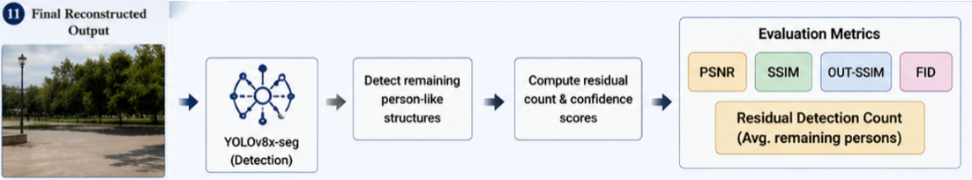
Figure 4: Residual-aware evaluation
The final system is not just a very simple inpainting approach; it is a full framework for removing all objects from an image. In particular, the whole framework includes the following components (in order): dataset selection, automated detection of individuals, generation and refinement of masks, contextually aware processing, global reconstruction of background, local enhancement using diffusion, second-pass refinement, and evaluation based on residual detection. The complete methodology is summarized as follows: first, detect all of the person instances in the input image; next, perform enhancement on each mask used for removing an individual to make it into a clean area for removing the individual; finally, take the combined image and mask generated from the previous two steps and pass them into LaMa for reconstructing the overall structure of the image; then, take the reconstructed area and enhance it with local restoration techniques; lastly, evaluate the resulting combined image against a combination of aesthetic and residual evaluation metrics. The overall architecture of the entire system as illustrated in Figure 5, gives a summary of how each of the components of the framework comes together as a whole functional unit.

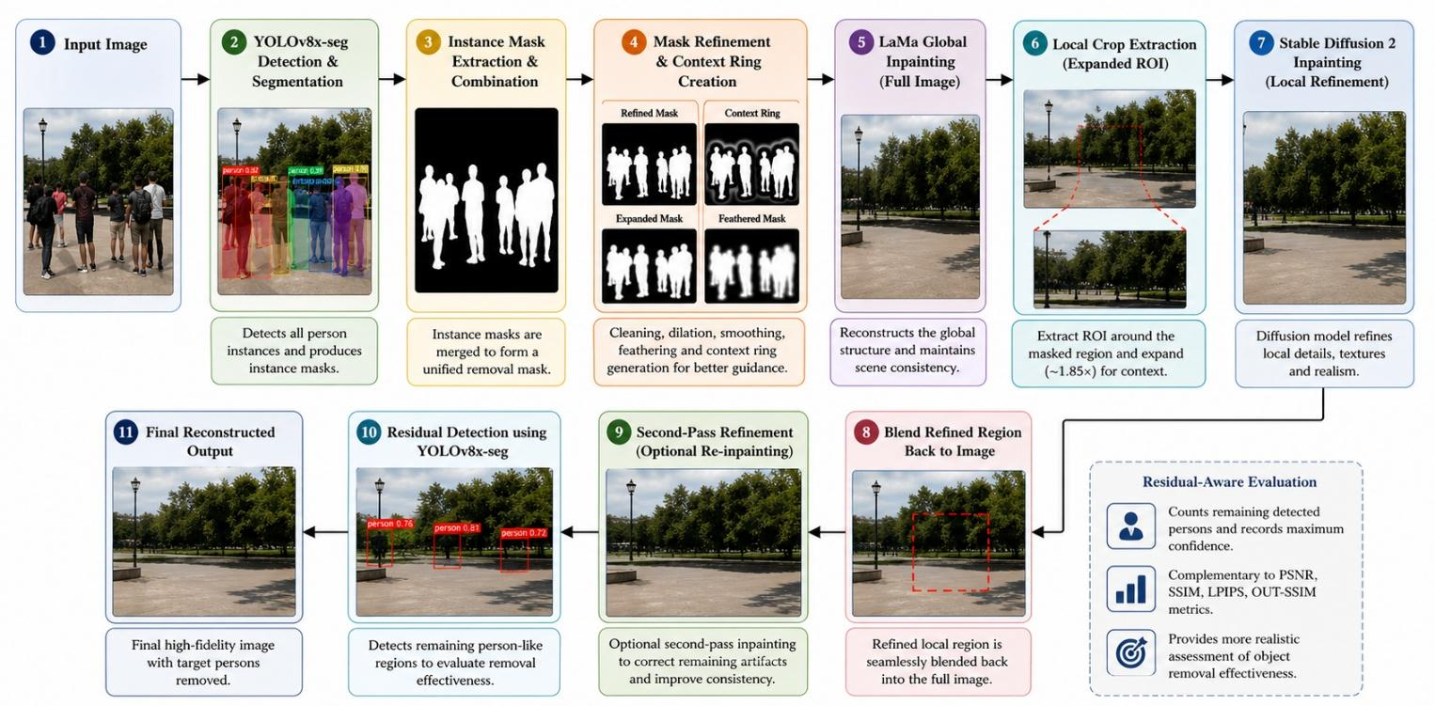
Figure 5: Proposed system architecture

3.2 Hardware and Software Components
The proposed system for removing objects through instance-level recognition is based on a fusion of the latest deep-learning architectures, image editing algorithms and rolling along with GPU-enhanced computations. Because the full pipeline includes detection, segmentation, mask fine-tuning, global refinement, local diffusion and evaluation, this system needs to operate both efficiently and in a high level of integration.
The main data considered for this research consists of a manually reviewed sub-collection of real-life images represented within the MS COCO dataset that features a range of human activity in individual or multiple human instances. An ample selection of 200 individual images was used to identify various realistic scenarios that represented groups of people including, low density or high density in groups, crowded locations, and items with substantial scale. In order to perform a useful evaluation of the data considered within the study, a threshold for filtering out very small or excessively large masks was implemented. To ensure reproducible dataset filtering, the combined person-mask area was calculated as a percentage of the total image area. Images were excluded if the combined mask area was less than 2% or greater than 35% of the image area. These thresholds removed cases where the target region was either too small to provide meaningful reconstruction difficulty or too large to provide sufficient surrounding context. After applying this filtering step, the dataset was reduced from 200 images to 104 valid samples.
The YOLOv8x-seg model processes object detection and segmentation through the same system by performing both bounding box detection and pixel detection. To assist with accurately detecting the person instances, a 0.25 confidence threshold is set on the model’s output when producing bounding boxes. YOLOv8x-seg was selected because of its ability to detect multiple objects quickly, as well as being able to function under harsh environmental conditions. Previous testing was done using SAM for mask production; however, the use of YOLOv8x-seg was ultimately chosen because it could process extensive amounts of data automatically, without user interaction.
To improve masks created with the YOLOv8x-seg model, OpenCV’s classical techniques will be applied to refine the mask uses (e.g., noise removal) will include combo techniques (e.g., closing and opening) will be used to clean up noisy results and fill gaps; dilation will be used to expand the masked area of the image; and Gaussian smoothing will be used to soften the boundaries of the newly created masks. Various feathering techniques will be used to create a more seamless transition between the masked and non-masked areas. A ring will be added around the masked area that will create context so that reconstruction algorithms can make use of the additional surrounding spatial information.
The first step in the Inpainting Process is Rebuilding the Global Image Using LaMa: LaMa was chosen as the Global Rebuild option due to its ability to reconstruct larger missing areas with the help of global contextual information and its ability to maintain structural consistency over larger masked areas with great efficiency. Because of LaMa’s tendency to produce smooth textures, it was combined with the Diffusion-based Fine-Tuning Process that follows it.
The second step used to produce the Fine-Tuned Image of the Masked Image is Local Reconstruction Using Stable Diffusion 2, which is a Stable Diffusion model trained to perform inpainting via the Hugging Face Diffusers Library. The local area of interest for inpainting is a cropped area around the masked region thus enabling the model to concentrate on detailed local features without impacting the larger section of the original image being reconstructed. The local Diffusion model includes 30 inference steps with a guidance scale of 7.5, which assist with equalizing realism/stability when creating the Fine-Tuned Image for the Masked Image.
Reconstruction and detection-based methods of evaluation are used. Structural and perceptual similarity between original and reconstructed images are measured with PSNR, SSIM and LPIPS (Image Quality Metrics: PSNR, SSIM, LPIPS). OUT-SSIM is also evaluated to see how well non-masked areas were preserved during reconstruction.By using YOLOv8x-seg to look for any remaining persons in the reconstructed images, the effectiveness of object removal (oval notation) is determined using this residual detection method for a more accurate evaluation of object removal performance
The implementation is done in Python and relies on important libraries such as PyTorch, for deep learning, OpenCV, for image processing, and Diffusers, for diffusion-based inpainting. All experiments are conducted in a GPU-enabled environment (Google Colab or Kaggle) using NVIDIA GPUs (such as Tesla T4 or A100) to manage large models and process high-resolution images quickly.
TABLE I. SOFTWARE AND TOOLS USED
Tool | Functions | Other similar Tools | Why selected this tool
YOLOv8x-seg | Object detection & segmentation | Mask R-CNN, Detectron2 | Fast, accurate, unified detection & segmentation
LaMa | Global image inpainting | DeepFill v2, EdgeConnect | Strong performance on large masks, efficient
Stable Diffusion 2 | Local refinement | DALL·E, Imagen | High-quality texture and semantic generation
PyTorch | Deep learning framework | TensorFlow | Flexibility and compatibility with models
OpenCV | Image processing | PIL, skimage | Efficient mask processing operations
Diffusers | Diffusion model integration | Custom implementations
  Easy integration of Stable Diffusion

TABLE II. HYPERPARAMETERS USED IN THE PROPOSED FRAMEWORK
Component | Hyperparameter | Value
YOLOv8x-seg | Detection confidence threshold | 0.25
Residual detection | Confidence threshold | 0.20
Dataset filtering | Minimum mask-area ratio | 2%
Dataset filtering | Maximum mask-area ratio | 35%
Local crop | Expansion ratio | 1.85
Stable Diffusion 2 | Input size | 512 × 512
Stable Diffusion 2 | Inference steps | 30
Stable Diffusion 2 | Guidance scale | 7.5
Mask refinement | Closing, opening, dilation, smoothing | Applied
Evaluation | Metrics | PSNR, SSIM, LPIPS, OUT-SSIM, residual count

The hyperparameters in Table II were selected through empirical testing and iterative experimentation. Several configurations were evaluated during development, and the reported settings provided a practical balance between reconstruction quality, object-removal effectiveness, and computational efficiency.

3.3 Software Implementation
The proposed system is implemented in a structured multi-stage pipeline, where each stage operates sequentially enabling consistent processing and reproducibility. The proposed system will process the images using a fully automated approach; therefore, it will process images at a batch level and require no manual interaction.
The process begins by preparing the dataset by loading the selected COCO images and pairing them with the automatically generated segmentation masks. The mask will be generated using the YOLOv8x-seg model to find all of the person instances for an image and provide corresponding masks for those instances. The masks generated will be combined to create a single mask representing all locations to be removed from the images. This generated mask enables the proposed system to scale efficiently for large datasets.
The next stage is a mask refinement process where the outputs of the detection model (the original masks) are enhanced through morphological operations to improve the quality of the mask. Through closing operations, small holes are filled; opening operations remove isolated noise. After dilation to ensure there are no residual artifacts outside of the final object boundary, the mask can be smoothed by applying Gaussian smoothing or feathering to create smooth transition areas between masked and unmasked areas. A context ring is generated around the mask to provide additional information that will be utilized by reconstruction models.
At the global reconstruction stage, the refined mask and the original image are entered into the LaMa inpainting model; this model reconstructs the masked area based on global context (from areas surrounding the masked area in the image). This stage results in a structurally consistent image at this stage, but may not contain fine detail in places where the complexity of the scene was large.
The system's local refinement stage has a local refinement stage that utilizes Stable Diffusion 2 inpainting to improve upon the detail of the localized area. A region of interest has been extracted around the area that was masked; this region has been expanded outward from the masked area by about one hundred eighty-five percent to include any context that may surround the masked object. The region that was extracted from the newly produced content has been resized to have a fixed size of 512×512, and the new region will be passed through the diffusion model (Stable Diffusion 2). As a result, the refined localized region is going to generate new content that improves the visuality of the texture, blends with surrounding regions, and enhances the perceived realism of what was historically present in the original image. Once the localized region has been generated through stable diffusion, this will allow for that local region to be placed back into the global content.
Upon completion of the first area of reconstruction, we may run a second pass of refinement over the newly reconstructed area. In this second stage of refinement, the reconstructed area will be corrected for small artifacts and visual inconsistencies. Although this process of having two passes is not required for each reconstruction, it allows for the system to have increased robustness and the opportunity to correct any artifacts associated with only using one pass.
After creating the newly reconstructed content, the system will apply the residual detection process to verify that all of the objects that were previously present before doing any inpainting have been successfully removed. To accomplish this, we will use the YOLOv8x-seg model once again on the newly reconstructed image, so as to identify any remaining instances of persons. The number of instances and the level of confidence (associated with each detected instance) will be collected in the evaluation and metrics for verifying the success of object removal.
The evaluation metrics include Peak Signal-to-Noise Ratio (PSNR), Structural Similarity Index Measure (SSIM) and Learned Perceptual Image Patch Similarity (LPIPS) to gauge the quality of reconstruction of the image and OUT-SSIM to measure accuracy of the non-masked regions; global and local inpainting times; total time taken to complete the entire pipeline; these evaluation metric will then be saved in a standardized format in the form of CSV files to allow for further analysis.
The complete end-to-end implementation of this pipeline demonstrates an integration of all pipeline components (detection, segmentation, mask refinement, hybrid inpainting and evaluation). By developing each of the pipeline components as separate modules, changes and/or improvements can be made to each module independently, which offers flexibility for future research and enhancements to this system.

Chapter 4 Experiment, Result, Analysis and Discussion
This chapter presents the experimental investigation, results, and analysis of the proposed instance-aware object removal framework. The evaluation is conducted in a structured manner, beginning with baseline comparisons, followed by progressive improvements, hybrid method analysis, and final-stage evaluation on the processed dataset. Both quantitative metrics and qualitative visual analysis are used to assess reconstruction quality and object removal effectiveness.

4.1 Experimental Setup
For these experiments, a publicly available dataset called MS COCO contains many images with more than one human instance. To perform the experiments, a total of 200 images were found to contain at least two humans before elimination based on mask area ratio leading to 104 qualifying images for evaluation. The elimination process was based on the combined mask-area ratio. Images with a mask area below 2% or above 35% of the total image area were removed to ensure a fair and reproducible evaluation.
Following the process flow defined in Chapter 3, all chosen images went through the entire process of extracting and refining segmentation masks, completing inpainting through both global reconstruction using LaMa and local reconstruction with Stable Diffusion v2, and (optionally) re-contextualizing the output via a second pass.
Evaluation was done using two types of evaluation metrics: reconstruction-based metrics and detection metrics. By constructing the difference between input and output images, PSNR, SSIM, and LPIPS were used as reconstruction-based metrics. Additionally, in order to evaluate how well the non-masked areas of the image have been maintained (or preserved) from the original input image, OUT-SSIM was used. To evaluate the effectiveness with respect to the number of removed objects in images, object detection metrics were used. YOLOv8x-seg was used to record the number of remaining detected objects (humans) in the image.
Processing time is also measured for each stage, including global inpainting, local refinement, and total pipeline execution time.

4.2 Baseline Comparison
To establish a reference point, the proposed method is compared against several baseline approaches, including classical inpainting methods and learning-based models. The baseline methods were evaluated under a synthetic full-image reconstruction setting. The baseline methods include OpenCV Talea, OpenCV Navier–Stokes, Lama-only reconstruction, Stable Diffusion-only inpainting, and combined approaches of LaMa and Stable Diffusion.

TABLE III: QUANTITATIVE COMPARISON OF FIVE PRETRAINED INPAINTING BASELINES EVALUATED ON THE SAME IMAGE SUBSET.
Method | Type | PSNR Full ↑ | SSIM Full ↑ | LPIPS Full ↓ | Residual Count ↓ | Time (s) ↓
Telea | Classical | 14.544 | 0.691 | 0.349 | 0.870 | 0.140
Navier-Stokes | Classical | 14.668 | 0.691 | 0.345 | 0.800 | 0.161
LaMa | Deep global inpainting | 14.700 | 0.539 | 0.327 | 1.765 | 0.211
Stable Diffusion 1.5 | Diffusion | 13.690 | 0.462 | 0.366 | 1.600 | 5.710
Stable Diffusion 2 | Diffusion | 13.581 | 0.467 | 0.364 | 1.290 | 5.350

Experimental results demonstrate that classical methods including Telea and Navier–Stokes achieve a high PSNR and SSIM when tested with smaller or moderate masked regions (for example, Navier–Stokes achieved a PSNR in the region of 15.9 and an SSIM in the region of 0.73 as determined through synthetic evaluation methodologies). However, these classical approaches fail to create semantically meaningful content in large areas of masking, instead producing blurred or otherwise unrealistic textures.
In contrast, LaMa shows strong performance in global structure retention, achieving a level of visual coherence that offers an enhanced perception over the classical techniques. Conversely, diffusion methods offer us a more realistic means of creating a texture but have a degree of instability in regards to the large masked areas on which they are worked. For example, when using diffusion-only methodologies, output variability is common to occur when masking covers a large area.
The hybrid methodology of LaMa and Stable Diffusion provides an improved level of visual coherence compared to either of their individual approaches. LaMa serves as a stable structure and Stable Diffusion serves to enhance local detail; however, the hybrid methodology also comes at the cost of additional computational time.

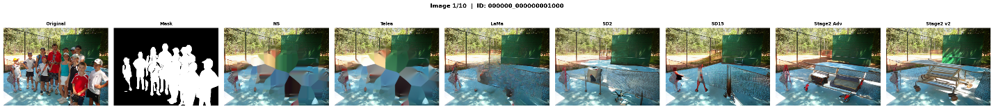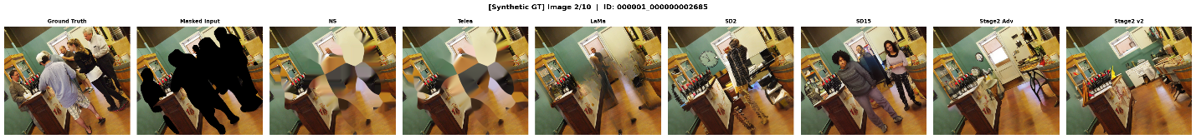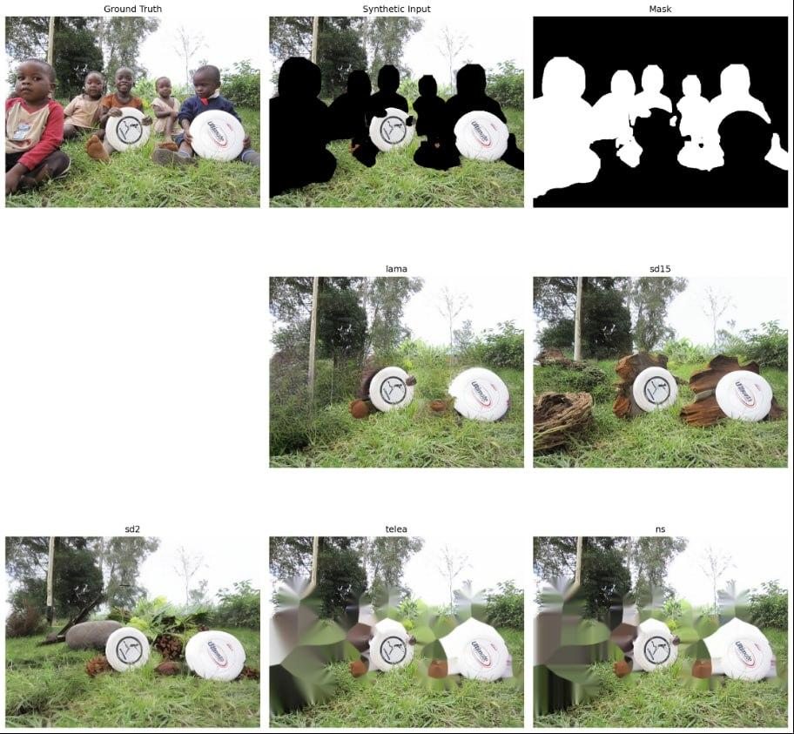
Figure 6: Baseline comparison visual grid
.
Figure-6 shows outputs from Navier–Stokes, Telea, LaMa, Stable Diffusion, and hybrid methods for the same input image

4.3 Progressive Removal Analysis
During the system's development process, it became evident that the larger the combined mask area, the more unreliable single-shot removal becomes. The single-shot removal method corresponds to Method A, which combines a single removal (or inpainting) for all detected person masks and removes that merged mask in one action. The progressive removal method (Method B) starts removing the largest instance of a detected person first and then progresses to remove additional detected persons one by one until they are gone. Using the progressive removal approach has allowed for more manageable sized removed masked areas than when all removed masked areas are done in one shot.

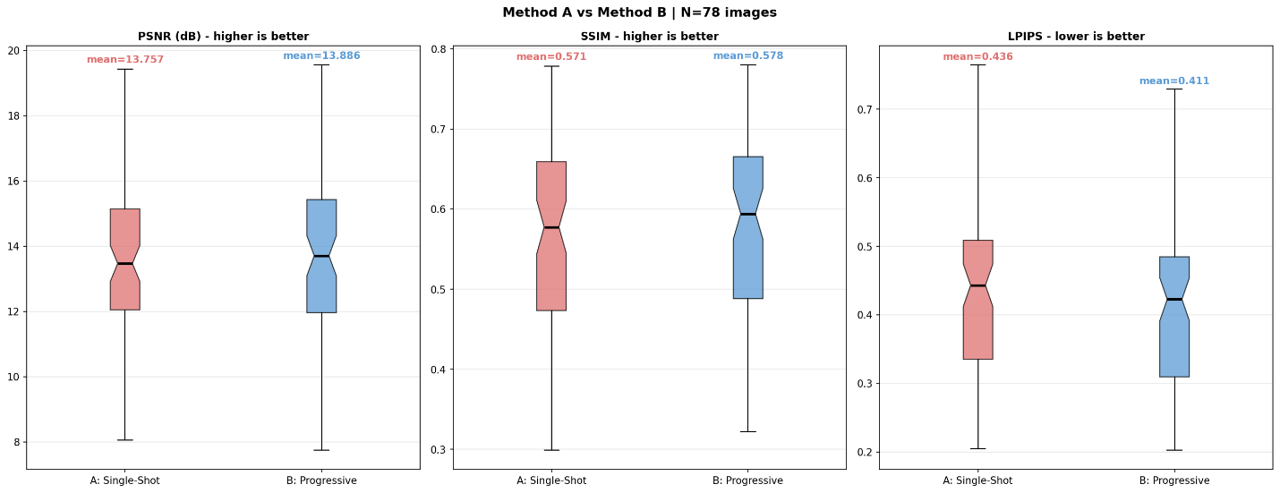
Figure 7: Metric comparison between Method A single-shot removal and Method B progressive instance-wise removal

As shown in Figure 7, Method B produced slightly better average PSNR and SSIM values than Method A. The average PSNR improved from 13.757 dB to 13.886 dB, while SSIM increased from 0.571 to 0.578. Although these improvements are small, the LPIPS score improved more noticeably from 0.436 to 0.411, indicating better perceptual similarity and more visually realistic reconstruction.

TABLE IV: QUANTITATIVE COMPARISON BETWEEN SINGLE-SHOT REMOVAL AND PROGRESSIVE INSTANCE-WISE REMOVAL
Method | Strategy | Samples | PSNR ↑ | SSIM ↑ | LPIPS ↓ | Time (s) ↓
Method A | Single-shot removal | 78 | 13.757 | 0.571 | 0.436 | 0.196
Method B | Progressive instance-wise removal | 78 | 13.886 | 0.578 | 0.411 | 1.084

The per-image win-rate analysis in Figure 8 further supports this finding. Method B outperformed Method A in 42 out of 78 images for PSNR, 58 out of 78 images for SSIM, and 72 out of 78 images for LPIPS. This means the progressive method achieved a 92.3% win rate based on LPIPS, showing that it was more effective in improving perceptual quality. However, this improvement comes with increased computational cost because progressive removal requires multiple inpainting passes for each image.

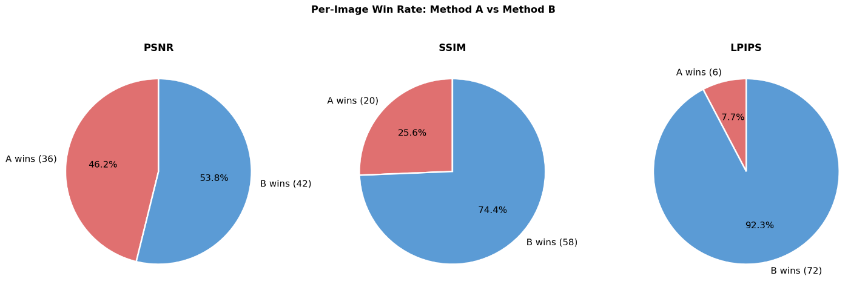

Figure 8: Per-image win-rate comparison between Method A and Method B across PSNR, SSIM, and LPIPS.

4.4 Multi-Method Comparison and Trade-off Analysis
In the next round of testing there were several variations of our pipeline assessed to look at how well reconstruction quality and ability for object removal trade-off against each other. Four different methods were compared in this testing. Method A represents a global single shot person removal, with all instances of detected persons combined and then removed in one step of inpainting. Method B represents a global progressive person removal in which all detected persons will sequentially removed as opposed to being removed all together. Method C represents a progressive local crop-based removal of the detected persons, with regions of local processing around each detected person processed in such a way as to maintain more background topography. Finally, Method D represents a hybrid global retention and residual refinement of detected person instances, where residual person-like regions will again be detected and then refined to reduce the presence of unwanted objects.
The resulting data clearly indicate that there is a trade-off among visual reconstruction quality and the strength of object removal. Specifically, Method C had the largest amount of visual reconstruction quality, evidenced by the PSNR at 13.96, the SSIM at .583 and the LPIPS at .387. Therefore, local crop-based refinement was more successful than the other methods in maintaining background topographic structure, resulting in a more visually appealing refinement with respect to the detected persons. Nevertheless, Method C did not yield 100% object removal of all detected persons, further demonstrating that a higher level of visual quality does not necessarily yield a higher level of overall object removal.
TABLE V: MULTI-METHOD COMPARISON SHOWING THE TRADE-OFF BETWEEN RECONSTRUCTION QUALITY AND RESIDUAL OBJECT REMOVAL
Method | Strategy | PSNR ↑ | SSIM ↑ | LPIPS ↓ | OUT-SSIM ↑ | Remaining Persons ↓ | Time (s) ↓
Method A | Single-shot global removal | 13.355 | 0.453 | 0.434 | 0.545 | 3.130 | 0.167
Method B | Progressive global removal | 12.794 | 0.397 | 0.492 | 0.476 | 4.385 | 1.047
Method C | Progressive local crop-based removal | 13.963 | 0.583 | 0.387 | 0.687 | 4.125 | 0.382
Method D | Hybrid residual refinement | 12.736 | 0.398 | 0.546 | 0.475 | 0.010 | 0.958
In contrast, Method D achieved the strongest residual removal performance, with the average remaining person count reduced close to zero. This shows that residual refinement was effective in suppressing detectable person-like regions. However, Method D produced lower reconstruction quality compared to Method C, indicating that aggressive residual removal can degrade visual realism and structural consistency.
Figure 9 presents the quantitative comparison of Methods A–D across reconstruction and residual-removal metrics, while Figure 10 further analyzes the effect of mask area coverage and number of persons on performance. These findings show that object removal requires balancing two competing goals: producing visually realistic reconstructed backgrounds and fully suppressing the removed object. A method may achieve strong PSNR, SSIM, or LPIPS values while still leaving detectable object traces, whereas a method that strongly removes residual objects may introduce more visual artifacts.
A vs B vs C vs D | Metric Distribution
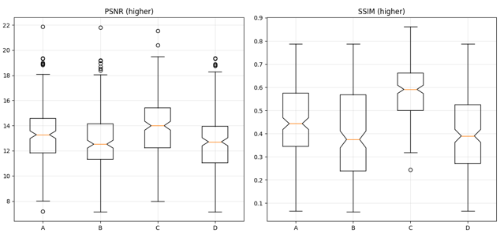
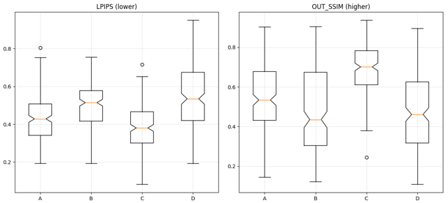
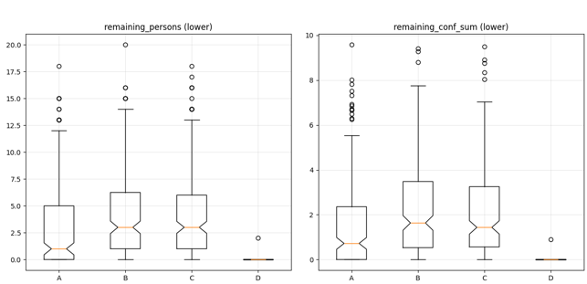
Figure 9: Per-image performance comparison of Methods A–D across PSNR, SSIM, LPIPS, and residual detection metrics, highlighting the trade-off between reconstruction quality and object removal effectiveness.

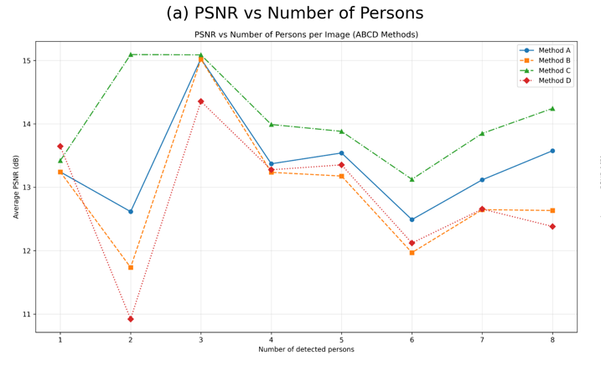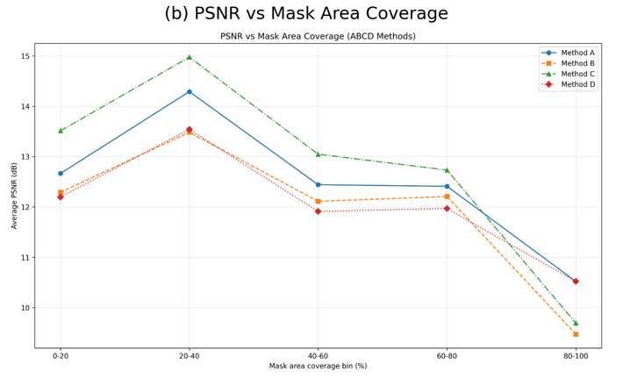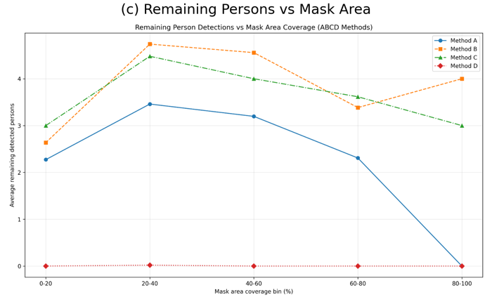

Figure 10: Trade-off analysis of reconstruction quality and object removal effectiveness under increasing scene complexity.
(a) PSNR decreases as mask area coverage increases, highlighting the difficulty of reconstructing large missing regions.
(b) Remaining detected persons decrease significantly for the hybrid method, demonstrating superior object removal capability.
(c) PSNR variation with the number of persons indicates performance degradation in crowded scenes.

4.5 Stage-wise Development of the Final Pipeline
Through multi-method comparison and trade-off analysis, the experimental findings were compiled into a structured and repeatable pipeline. Instead of being treated as independent experiments, detection, masking and reconstruction were staged within the system in such a way that there was maximum potential for consistency, stability and scalability.
The beginning of the pipeline was the unified data preparation stage, which collected 200 person instance images from a COCO-style dataset. Each of the 200 images was then processed via YOLOv8x-seg, which resulted in a set of instance segmentation masks. With all images being supplied with the same instance mask structure, they were prepared to form the basis of all subsequent processing and evaluation.
The next stage of the pipeline was the filtering stage, which facilitated improved data quality and consistency. During this stage, all automatically generated masks were evaluated by their coverage and structure, images with combined mask-area ratios below 2% or above 35% were removed, along with noisy masks that were unsuitable for reliable evaluation. The result of this process was a refined data set of 104 images. This new set of 104 images was then split into structured experimental splits for controlled experimentation, providing a consistent method for assessing pipeline performance across multiple configurations.
The pipeline used to create the core component was designed in several stages with the purpose of detecting, refining masks, reconstructing, and then refining locally all data acquired in the previous design stages. Once detected, the raw mask data was subjected to morphological processing which served to create a smoother boundary by removing noise, filling gaps, and improving the quality of the boundaries. Smoothing, feathering, and other techniques were applied to reduce the transition from the mask to the original image by means of contextual references within a ring surrounding the masked area.
The reconstruction stage has been accomplished with a hybrid global and local inpainting approach. A global inpainting model (LaMa) was first employed to reconstruct the overall structure of the scene and to ensure that spatial relations are consistent throughout the image, but due to the limitations of a global reconstruction model alone being capable of producing smooth or less detailed texture, a second phase was used for local refinement of detail in the form of a diffusion-based inpainting model (Stable Diffusion 2). Thus, the local region was cropped around the area of the mask for local detail improvement and perceptual high-quality realism. Finally, the refined local detail was blended back into the original full-size image with smooth transitions to minimize any visible seams or edges.
To further improve the systems' stability and overall quality of output, further refinement processes were introduced into the pipeline. The mask boundaries were treated in a more consistent manner, to minimize edge artefacts, and blending operations were enhanced to provide seamless integration between original and reconstructed regions of the imagery. The execution flow was also restructured/stabilised, which accommodates more complex situations (overlapping masks and large areas of removal) and provides more consistent results for the variety of scenes evaluated.
A lightweight learning-based model was also tested in a new refinement stage, which tried to learn to make residual corrections on top of the already reconstructed outputs, using a compact U-Net architecture trained using synthetic data. While the method showed a slight improvement in some instances, it did not show consistent advantages over the hybrid reconstruction pipeline, and was therefore not incorporated into the final system; however, it may be worthy of consideration for a potential future direction.
This stage-wise evolution of the system has transformed it into a cohesive structure that integrates: i) instance-aware detection, ii) refined mask creation, iii) global structure reconstruction, and iv) local diffusion-based enhancement. As a result of this structured design, the final evaluation (presented in the next section), is based on a stable and scalable foundation for use in the final system.
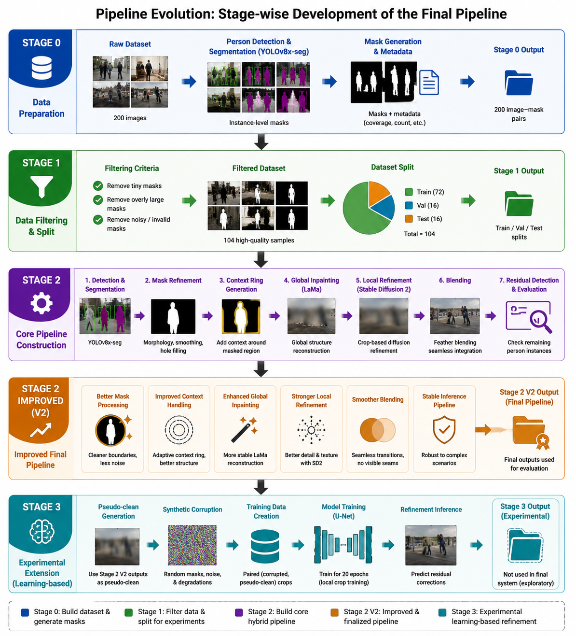
Figure 11: Stage-wise evolution of the proposed instance-aware object removal pipeline.
Figure-11 shows the system progresses from initial data preparation and filtering to a hybrid global–local reconstruction framework. The improved Stage 2 (V2) represents the finalized pipeline used for evaluation, while Stage 3 illustrates an experimental learning-based refinement extension.

4.6 Final Proposed Method Evaluation
The concluding method being proposed here is known to be the upgraded Stage - 2 Pipeline which consolidates all the modification that happened through the course of creating the product. The pipeline has the following; Refined Mask Processing, Contextual Aware Cropping, Global Reconstructions Using LaMa, Local Refinement Using Stable Diffusion 2, Smooth Blend, and Second Pass Refinements. The Final Method was evaluated using filtered data of 104 unique multi-person photos.
The final pipeline produced average PSNRs of approximately 18.17, SSIMs = 0.713, and OUT-SSIM of 0.774. Therefore, based on those results we can conclude that the proposed method did produce reconstructed masked areas of a relatively good quality structurally while significantly retaining all corresponding non-masked areas. In contrast, the final pipeline provides a greater amount of stability and quality overall to the previous experiments’ results, particularly when the area removed has moderate coverage.

TABLE VI
: FINAL PERFORMANCE SUMMARY OF THE PROPOSED STAGE 2 V2 PIPELINE ON EVALUATED SAMPLES.
Metric | Value
Evaluated samples | 104
Final mask area ratio | 0.160
PSNR region ↑ | 18.170
SSIM region ↑ | 0.713
OUT-SSIM ↑ | 0.774
LPIPS full ↓ | 0.000062
Residual count ↓ | 6.962
Residual max confidence | 0.916
LaMa global time | 0.924 s
Local diffusion time | 7.013 s
Total time | 7.937 s

However, residual detection analysis shows that complete object removal remains challenging. The average number of residual detections found was approximately six-point-nine-six. Several of these samples also exhibited a very high degree of confidence in the residual detections. This indicates that although the resulting image may look smooth to the eye, the residual detector was still able to detect structures or features that were similar to persons. This suggests that there is a need for an evaluation metric that incorporates residuals when completing tasks that remove objects from an image, as traditional evaluation metrics for reconstructing images are unable to quantify the effectiveness of an object removal adequately.
In addition to this finding, a computational analysis has also demonstrated a clear trade-off between quality of reconstruction and processing time. For example, images processed using the LaMa global inpainting method had an average processing time of approximately zero-point-nine-two (0.92) seconds each. On the other hand, images processed using the Stable Diffusion 2 local refinement method had an average processing time of approximately seven-point-oh-one (7.01) seconds each. Thus, the total average processing time per image was approximately seven-point-nine-four (7.94) seconds. With this in mind, it can be concluded that the final method produces better results than classical methods at a higher computational cost.
Qualitative examples from the final proposed pipeline are shown in Figure 12. The success examples demonstrate that the hybrid global-local strategy is able to produce visually coherent and seamless reconstructed backgrounds after removing a person. The failure examples demonstrate that there are still some residual artifacts, blurred places, or detectable person-like structures; this is particularly true in high-density or large-mask removal situations. These various findings confirm the second major hypothesis of this project; as shown through both the quantitative and qualitative analysis, the method proposed here results in an improved quality of reconstruction, but achieving complete semantic removal in high-density multi-person scenes continues to be an ongoing challenge.
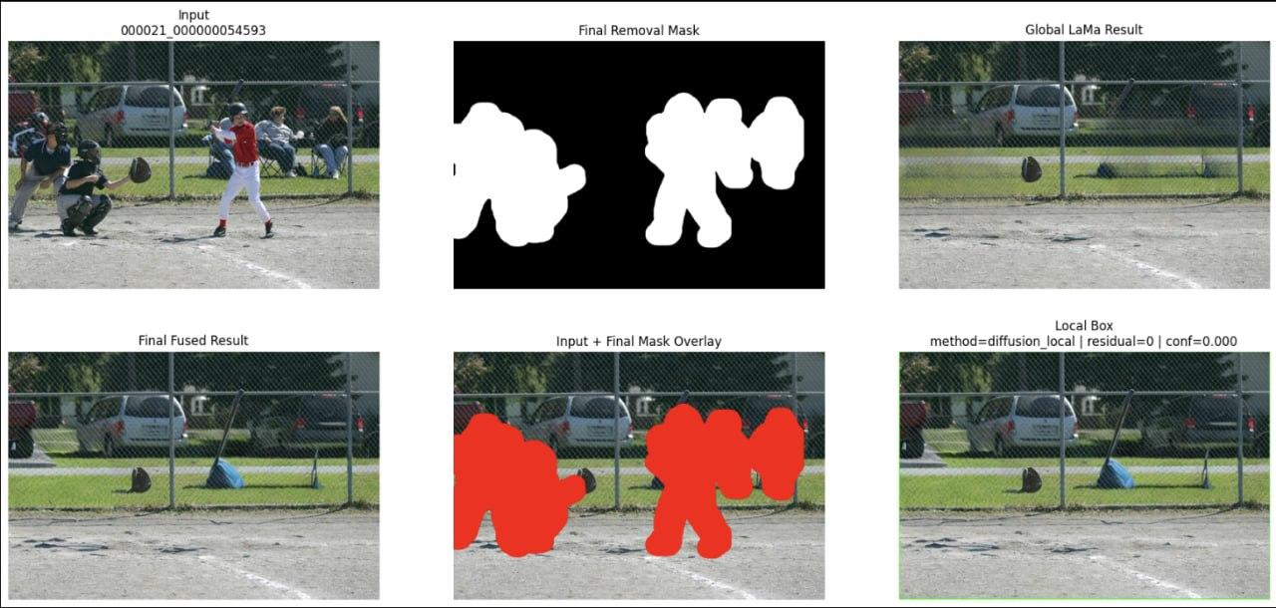
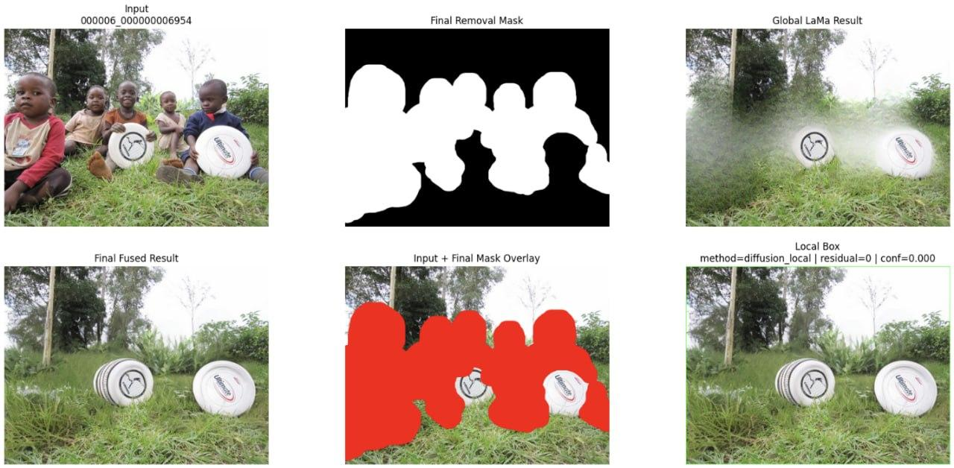
Figure 12: Qualitative results of the final proposed pipeline.

Figure-12 shows the input image, detection or mask information, and reconstructed output. The success cases demonstrate visually coherent background reconstruction.

4.7 Discussion
The findings from the experiments indicate that our new multi-stage framework produces reconstructed images of higher quality than previous methods that reconstruct images in one step. By using LaMa for the global part of the image and then refining the local portion with Stable Diffusion 2, the system is able to achieve both global structure as well as local texture and perceptual realism when presenting the reconstructed images to end users. Multi-method and stage by stage experiments conducted through progressive stages also demonstrate that the object removal retained the original structure of the scene's objects. The object removal relies heavily on mask size, complexity of the scene and a balance of reconstruction quality to residual suppression.
We found that the visual quality of the reconstructed scene does not always imply complete removal of the object(s). While Method C produced significantly higher reconstruction metrics when compared to the other methods the original object(s) still had some structure that could be detected after all the repairs were completed. However, while Method D removed the original structure more effectively, the aggressive refinements used to produce the high quality images have degraded the quality of the images visually. This demonstrates the importance of both reconstruction and detection metrics in evaluating the quality of the object removal.
In summary, the final version of V2 - Stage 2 showed improvements over previous experimental systems in terms of robustness and final reconstruction quality; however, it has many limitations at the moment. For example, very crowded scenes, regions with large masks or extreme overlapping of individuals in complex backgrounds often result in poor results. Additionally, the computational cost of the diffusion-based refinement process creates a slower method when compared to traditional inpainting approaches. Furthermore, the output quality is highly dependent on the accuracy of the detection and mask; poor mask generation will result in residual object boundaries, halo artifacts, or incorrectly removed backgrounds.The proposed framework provides a comprehensive and realistic solution to the problem of instance aware object removal, by integrating detection and refined mask generation, hybrid global-local reconstruction, and residual aware evaluation. The results demonstrate that this method enhances the quality of background reconstruction; nevertheless, achieving complete semantic object removal from complex real-world scenarios remains a significant challenge.

Chapter 5 Conclusions

5.1 Summary
This research presented an instance-aware object removal and high-fidelity background reconstruction framework for complex multi-person images. The main purpose of the project was to move beyond simple single-step inpainting and design a structured pipeline that can detect human instances, generate removal masks, refine mask boundaries, reconstruct missing background regions, and evaluate whether the removed persons still remain detectable after reconstruction.
An initial plan to improve the proposed person reconstruction methodology consisted of three parts; Detection, Reconstruction and Residual Analysis.The first step to detect and segment people in the image was accomplished by using the YOLOv8x-seg method to create a person instance mask. The mask images created by the YOLOv8x-seg method were then modified using a combination of morphological cleaning, dilation, smoothing, feathering and context-based techniques. LaMa was then applied to the globally reconstruct the background of the detected person instances, as its global scene structure retention capability was much more robust than other reconstruction methods. Stable Diffusion2 was then utilized as a local refinement model to enhance the visual realism and quality of the texture existing in the globally reconstructed background regions. Finally, a residual detection analysis was performed by applying the YOLOv8x-seg method on the final output, to determine whether there were any remaining person-like structures.
The experimental results provided several valuable insights. Classical type approaches such as Telea and Navier-Stokes methods; yielded quick segmentation and reasonable structural results for smaller sized segmentation masks, however were not effective for larger more complex semantic reconstructions. As expected, LaMa produced more robust global reconstructions with much more perceptually appealing than classical approaches to reconstruction; however LaMa generated the occasional smooth textures. While the Stable Diffusion approach provided good local visual refining of previously computed reconstructions; applying stable diffusion directly to large sized segmentation masks generated unstable and/or unrealistic output. Therefore the proposed hybrid solution proved to be more effective by combining the structural stability of LaMa's output with local refinement via Stable Diffusion.
On average, the final evaluated pipeline yielded approximately 18.17 PSNR, 0.713 SSIM, and 0.774 OUT-SSIM for the processed dataset. While these results show that the proposed process restored masked areas reasonably well, the method was also successful at maintaining non-masked areas. However, the results of the residual detection analysis revealed that the detection of all persons removed from an image was still problematic and averaged 6.96 residual detections per image. The implication of this finding is that assessing object removal cannot rely solely upon visual quality. A generated image may visually appear to be smooth yet could still contain structures that have characteristics of persons, which are detectable by a robust object detector.
In conclusion, this work provided clear evidence that a multi-stage hybrid inpainting framework is a viable approach for object removal in real-world conditions. The final product produced through this research represents not only a visual end product of high quality, but also a complete methodological process including: instance-aware detection, improved mask creation, global-local reconstruction, second-pass refinement, and residual aware evaluation of residuals. Therefore, this methodology as an entire construct is more comprehensive and research-oriented than would be possible through a simple experiment in image inpainting.

5.2 Limitations
While the proposed framework achieved reconstruction results, many remaining limitations exist. The first major limitation is that there are no true and clean ground-truth background images to evaluate reconstruction; the source images within the dataset are real-world COCO images, and therefore, there is no way to know what is actually behind the removed person in the original image being reconstructed. In this case, the evaluation relied upon proxy metrics, synthetic comparisons, masked-region metrics, and the detection of residual outputs. Thus, this evaluation is realistic but is not equivalent to a true paired ground-truth reconstruction.
The second limitation is the continued presence of remaining residual person detection. The detector continues to identify human-shaped structures in many of the reconstructed images after the final hybrid processing pipeline is applied. This could occur due to some reconstructed regions maintaining human-shaped textures in the region of reconstruction, the absence of the re-identified persons from the original image being reconstructed, or the sensitivity of the person detection algorithm to various types of partial human body-like patterns (e.g., limbs). As a result, while the residual detections should always be evaluated in relation to the complete detection of objects in the reconstructed images, they constitute a clear illustration that the complete removal of objects from images is a very difficult problem.
The third restriction is the cost of computing. Classical methods tend to run relatively quickly, but the final hybrid pipeline requires both LaMa and diffusion-based local refinement to be performed. LaMa was computed in approximately 0.92 seconds per image, while the diffusion-based local refinement was computed in approximately 7.01 seconds per image, resulting in an average total processing duration of approximately 7.94 seconds per image. Although the method does produce high quality reconstructions that may be appropriate for research purposes, it would not be suitable for real-time applications without additional optimisation.
The fourth limitation relates to the sensitivity of the mask. The quality of the detected segmentation mask will heavily impact the final output. If the mask is not large enough, between the mask and main subject, then there will still remain visible parts of the person. If the mask is too large, then important context surrounding the masked area is being removed, which makes reconstruction much more difficult. While mask refinement measures improved boundary quality, difficult cases due to occlusion, overlapping people, and crowded scenes will continue to remain difficult.
The fifth limitation is that the diffusion-based refinement is sometimes unstable. For example, while Stable Diffusion can improve local texture and realism, it can also introduce hallucinated (i.e. synthesised) content that was not present in the input crop when the input crop provides too few context or the masked area is too large. Therefore, the project confirmed that the main conclusion of the project was that diffusion models demonstrate great potential; however, they must be applied carefully in object removal jobs.

5.3 Future Improvement
The proposed system could be enhanced through additional avenues for future work. Constructing a synthetic paired dataset with images of the clean backgrounds would be an example. The object would be added then removed from each synthetic background image for a direct comparison of the two outputs (the reconstructions and the ground truth). A synthetic background dataset would provide a reliable means to evaluate the reconstruction quality as measured by PSNR, SSIM and LPIPS, due to the availability of true synthetic backgrounds.
The residual removal stage could be improved through the use of a refinement loop that is guided by a detector. In this method, the reconstructed image would be passed into a person detection system and any remaining person like areas would then be resampled and refined automatically. This could effectively reduce the residual number of detections and also enhance the ability to remove actual objects.
Improvements to the mask generation method would include the use of more powerful segmentation methods or an ensemble of segmentation methods. The combination of YOLOv8x-seg with an SAM, using ensemble methods, would result in more accurate masks because of the ensemble's ability to average masks that have been segmented compared to an individual segmentation method. Improved masks will contribute to improved quality of the reconstruction and reduced instances of halo artifacts.
A more controllable approach to diffusion refinement can be achieved in the future. Currently, the methods of generic diffusion inpainting are going to be limited to the type of prompts (i.e. how you want to inpaint) and how structural guidance (i.e. ControlNet) is applied, with respect to the background’s geometry, you also have the potential for reducing hallucination, and thus creating a more consistent image in complex scenes.
Learning-based local refinement will need to be evaluated more fully by introducing much more robust training sets as they relate to refined methods of this project, such as the lightweight U-Net model developed with pseudo-clean targets that failed to provide sufficient detail for smoothing purposes. With the combination of ground truth training sets (of paired data), and refined loss functions, such as perceptual, adversarial, and edge-aware losses, the utility of trainable models will be enhanced significantly through the implementation of improved local refinement models.

To summarize, the completed research created and determined the effectiveness of a full instance-based object removal framework for complicated multi-person situations. Hybrid inpainting showed that the mixing of global and local restoration techniques improved the quality of the reconstructed image; however, it was revealed that true object removal cannot be determined by visual similarity alone. The system described in this research will provide an excellent basis for future work on the realistic removal of objects from photographs, restoring background images, and developing image editing systems.

References

[1] J. Redmon, S. Divvala, R. Girshick and A. Farhadi,
"You Only Look Once: Unified, Real-Time Object Detection,"
in Proceedings of the IEEE Conference on Computer Vision and Pattern Recognition (CVPR), 2016, pp. 779–788.

[2] A. Kirillov et al.,
"Segment Anything,"
in Proceedings of the IEEE International Conference on Computer Vision (ICCV), 2023.

[3] R. Suvorov et al.,
"Resolution-robust Large Mask Inpainting with Fourier Convolutions,"
in Proceedings of the IEEE/CVF Conference on Computer Vision and Pattern Recognition (CVPR), 2022.

[4] R. Rombach et al.,
"High-Resolution Image Synthesis with Latent Diffusion Models,"
in Proceedings of the IEEE/CVF Conference on Computer Vision and Pattern Recognition (CVPR), 2022.

[5] A. Lugmayr et al.,
"RePaint: Inpainting using Denoising Diffusion Probabilistic Models,"
in Proceedings of the IEEE/CVF Conference on Computer Vision and Pattern Recognition (CVPR), 2022.

[6] M. Bertalmio, A. L. Bertozzi and G. Sapiro,
"Navier-Stokes, Fluid Dynamics, and Image and Video Inpainting,"
in Proceedings of the IEEE Conference on Computer Vision and Pattern Recognition (CVPR), 2001.

[7] A. Telea,
"An Image Inpainting Technique Based on the Fast Marching Method,"
Journal of Graphics Tools, vol. 9, no. 1, pp. 23–34, 2004.

[8] D. Pathak, P. Krähenbühl, J. Donahue, T. Darrell and A. A. Efros,
"Context Encoders: Feature Learning by Inpainting,"
in Proceedings of the IEEE Conference on Computer Vision and Pattern Recognition (CVPR), 2016.

[9] J. Yu et al.,
"Free-Form Image Inpainting with Gated Convolution,"
in Proceedings of the IEEE International Conference on Computer Vision (ICCV), 2019.

